# Table of contents

1 Table of contents 1

2 Introduction 2

2.1 Background 2

2.2 Purpose 2

2.3 Terms & definitions 2

3 Installation 3

4 Configuration 3

4.1 RSMPGS1.ini 3

4.2 SXL 4

5 Starting the simulator 4

6 Main Window 5

6.1 Sites and objects 5

6.2 System log 5

6.3 Generic 7

6.4 File 7

6.5 Process Image 8

6.6 Connection 8

6.7 RSMP 9

6.8 Alarms 10

6.9 Aggregated status 12

6.10 Status 13

6.11 Commands 14

6.12 Test send 14

7 Debug form 15

8 Change log 17

# Introduction

This document describes the interface simulator for Road side systems which are communicating with RSMP.

## Background

The Swedish Transport Administration has historically had a regional responsibility for the procurement and maintenance of technical systems. This has caused a non-homogenous view regarding functionality and interface issues in conjunction with supervision systems. Furthermore, the focus has been on the protocols of specific technical areas and suppliers, which has caused that there are limited opportunities to gather all systems into a national system. As a more national view has been established, the need for a national standard has arisen. This standard should be scalable, expandable and should have well defined interfaces between different levels.

## Purpose

The purpose with RSMP is to create a standardized way for communication between systems on a local level and systems on a regional level, regardless of supplier and technical area. It should be possible to add and extract signals in new types of systems and applications without having to change the standard. This means that the protocol, in contrast to many other standards and protocols, should not contain detailed information about signal exchange. Instead, the aim is to define signal types which then are described according to specific systems or objects. The goal is that in the long term, based on installedsystems and objects, is to be able to produce signal exchange lists of type object that can be reused in newcontracts so that alarm messages, commands, etc. have the same names regardless of facility or provider.

The purpose of the signal exchange is to provide information relating to, for example, traffic control managersand administrators. E.g. the information needed to monitor and control the road side equipment, as well as the information that can be used for statistics and analysis of traffic and equipment status.

## Terms & definitions

|  |  |
| --- | --- |
| **Term** | **Description** |
| HMI | Human Machine Interface (User interface) |
| SCADA | Supervisory Control And Data Acquisition |
| OP | Operating Panel |
| GUI | Graphical User Interface |
| RSMP | RoadSide Messaging Protocol |
| JSon | JavaScript Object Notation |
| TCP | Transfer Control Protocol |
| IP | Internet Protocol |
| GPRS | General Packet Radio Service |
| RSMP2Citect | Interface between roadside and Citect |
| RSMPGS1 | Interface simulator for Roadside Equipment |
| RSMPGS2 | Interface simulator for supervision system |

Table 1. Terms& definitions

# Installation

Installation should be with the file RSMPGS1_1_0_1_5_Setup.exe

The installation program recommends a suitable folder.

RSMPGS1 is written in C# with Microsoft Visual Studio 2015 and requires .NET Framework 4.6.1.

|  |  |
| --- | --- |
| **Filename** | **Description** |
| RSMPGS1.exe | Main program |
| .\Settings\RSMPGS1.INI | Configuration of RSMPGS1 |
| .\Objects | Reference files (example) |
| .\Source | Source code |
| .\Documents | Manual, RSMP spec etc |

Files and folders which are included in the RSMPGS1 installation. All files/maps are placed under the installation folder.

# Configuration

## RSMPGS1.ini

All base configuration is made in .\Settings\RSMPGS1.INI

The INI-file has the following parameters in the *[RSMP]* section:

**IPAddress**

IP-address and port number at the location of the supervision system, e. g *192.168.123.20:12666.* The DNS name can also be used, e. g*ntsserver_2.trafikverket.se:12666*

**ReconnectInterval**

Reconnection attempts will use this interval if automatic reconnection has been selected in the interface. Interval in milliseconds.

**MaxDebugLines**Number of lines shown in the Debug-forms.

**DaysToKeepLogFiles**Number of days before the log files are automatically deleted.

**PacketTimeout**

Packet timeout in milliseconds. The time which RSMPGS1 waits for ack/nack before an error message are written in the system log and the packet is resent.

**WatchdogInterval**This interval will be used if cyclical watchdog has been selected in the user interface. The interval is in milliseconds.

**WatchdogTimeout**The watchdog timeout in milliseconds, set to 0 to ignore failed watchdogs.

**MaxEventsPerObject**Max number of events in the event views per object (oldest will be removed).

The INI-file has the following parameters in the *[AggregatedStatus]* section:

**BitText_1..9**Texts which are associated (and presented in the user interface) in tab *Aggregated Status*.

The INI-file also has a *[Main]* section where for instance the current user interface configuration is saved.



## SXL

RSMPGS1 cannot read the Excel-format which SXL is saved in. Every tab in the SXL must be saved as a comma separated text file (CSV- or SKV-file).

It is appropriate to name the file according to the content, e. g *alarm.csv, 41101.csv, commands.csv* etc. The files are saved in the sub-folder.*\Objects*. If the folder does not exist, it must be created. RSMPGS1 will create the folder automatically the first time the program is started. When the program is installed, several example files are included.

Do not forget to change or add a new revision number and save the first tab again if any change is made. RSMPGS1 will point out if any file in *.\Objects* is changed without revision number change.

It is important that the SXL-format follows the template and the recommendations, otherwise will not RSMPGS1 be able to read the information correctly. See the functional specification for more information on how to make manual completions if necessary.

# Starting the simulator

When RSMPGS1 is started it will automatically use the installation folder as the project folder.RSMPGS1 is expecting to find the *Settings* folder in the project folder.

If not already present, RSMPGS1 will create the folders *Objects* and *LogFiles.*

The program can also be started with the startparameter */path* to use another project folder, e. g to use *c:\RoadSide\TestConfig1* as a project folder:

*RSMPGS1.EXE /path:c:\RoadSide\TestConfig1*

In this way, it is possible to create shortcuts for an unlimited number of projects. These projects can also be run simultaneously.

# Main Window

The program has two forms, one main window and one (or several) debug windows.

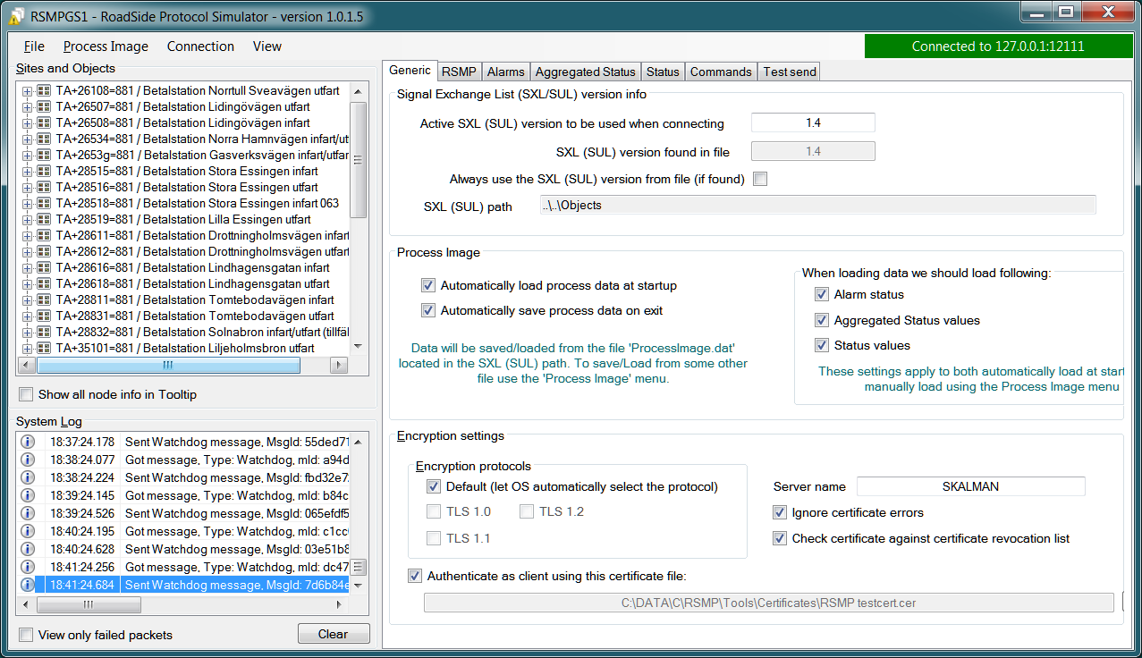

At the top right, there is a presentation of connection status to the supervision system. If the box is green, the connection is ok. The IPaddress is also showing. When connection attempts are performed, the box is grey.

If there is no connection the box is red.



## Sites and objects

At program startup the entire SXL is read from *.\Objects* and an hierarchical tree structure is built to the left. Clicking on an object group or object selects what should be presented on the tabs to the right.

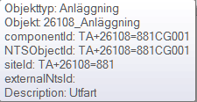

When hovering over a node and *’Show all node info in Tooltip’* is selected, tooltip will show all information that RSMPGS1 have been able to read about respective objects.

## System log

Down to the left, the system log is shown which display all occurring events, for instance if messages are received, if errors occur or a connection is established.

All events in the system log are continuously saved in ordinary text files in the folder *.\LogFiles\SysLogFiles* and marked with today’s date. The files are automatically deleted when they are too old (according to settings in *RSMPGS1.INI*).

The System log will show different status icons, depending of the message itself (info, warning, error).

If *View only failed packets* is selected, the System log will only show failed packets.

Click *Clear* to empty the System log list. The System log files will not be deleted.

## Generic

Various information concerning the connection to the supervision system is configured here.

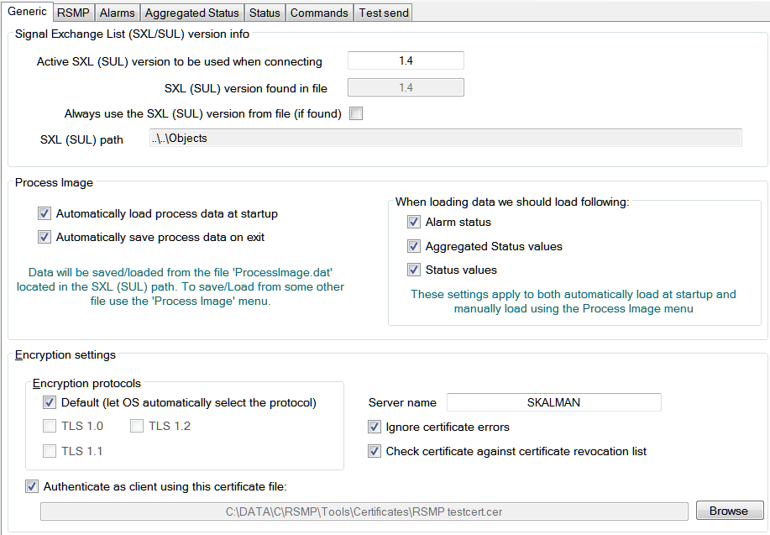

When RSMPGS1 is connected to the supervision system, information about SXL and the RSMP-interface version is sent over for the software to determine whether communication is possible or not.

***Active SXL (SUL) version to be used when connecting***  
SXL version which is sent over via the protocol when connection is made.

***SXL (SUL) version found in file***  
SXL version which is found in reference files in *.\Objects* folder.

***Always use SXL (SUL) version from file (if found)***  
Select to always use version number from the SXL files in protocol negotiation.

***Automatically load process data at startup***  
Select to always load the last roadside data from *ProcessImage.dat* at startup

***Automatically save process data on exit***  
Select to always save the last roadside data to *ProcessImage.dat* when exiting *RSMPGS1*

***When loading... Alarm status***  
Select to load last Alarm status from *ProcessImage.dat* during startup (if *Automatically load process data at startup* is selected)

***When loading... Aggregated status values***  
Select to load last Aggregated status from *ProcessImage.dat* during startup (if *Automatically load process data at startup* is selected)

***When loading... Status values***   
Select to load last Status values from *ProcessImage.dat* during startup (if *Automatically load process data at startup* is selected)

***Encryption protocols***   
The RSMP protocol specification defines it is possible to use encryption (from version 3.1.3) based upon SSL 3.0 or TLS 1.0. As SSL 3.0 have been deprecated by the Internet Engineering Task Force (IETF) the simulator only supports the never TLS protocols.

*Default* will let the OS select the .NET version most suitable protocol.

The simulator does not look in the server's certificate store (beside to validate the CA), the certificate to use must be pointed out by the server. The idea is that the simulator should be used for testing a specific certificate.

To enable encryption it must be selected in the *RSMP* tab.

***Server name***  
The server name is essential to validate the server certificate and is part of the negotiation process.

***Ignore certificate errors***  
During the negotiation of the encrypted connection the system log will show some info. If there are any certificate errors the connection will be closed unless this choice is ticked.

***Check certificate against certificate revocation list***  
Determines if the certificate should be checked against the revoced certificates and their CA's

***Authenticate as client using this certificate file***  
If also the client should identify itself using a certificate it may be selected here using the *Browse* button. If it is a pfx-file the simulator will also ask for a password. Be aware of that the password is stored Base-64 encoded in the INI-file.

## File

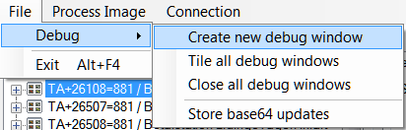

***Debug - Create new debug window***

Creates a new debug window. Any number of debug forms can be created, but it will affect performance.

***Debug -Tile all debug windows***  
Moves all debug forms to the right of RSMPGS1 (if there is space) and puts them in a line.

***Debug - Close all debug windows***

Closes all debug forms.

***Debug - Store base64 updates***

If checked, all incoming base64 encoded updates (commands) will be stored in the *DebugFiles* folder. The files will be named *Base64_* followed by date/timestamp.

***Exit***Closes RSMPGS1. Some process data is saved. Form settings (positions and what is marked) is saved in *RSMPGS1.INI*, so it looks the same at next program start.

## Process Image

The process image contains information about status, commands and alarms.

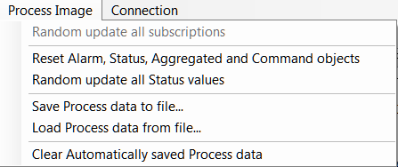

***Random update all subscriptions***

If a client is subscribing to status updates, this selection can randomly change them. If the subscriptions are updated by events, the new values are sent directly up to the client otherwise they will be transmitted when it´s time according to *UpdateRate*.

The values of data type *boolean*, *string* and *real* will be updated to *true/false, "0"/"1"* and -*1000.0..1000.0* respectively. All other data types will be updated to *-1000..1000*.

***Reset Alarm, Status, Aggregated and Command objects***  
Removes all alarms, status, aggregated status and command values. This can be done only when we are not connected.

***Random update all Status values***

Randomly change all Status values. This can be done only when we are not connected. Se data type value ranges above (*Random update all subscriptions*)

***Save Process data to file...***

Process data could be save to any file for later use. The process data file has a file ending of *.dat* but is basically a text file. The default process data file is the *ProcessImage.dat* file.

***Load Process data from file...***

Loads the process data file

***Clear automatically saved process data***

Removes the default process data file *ProcessImage.dat*.

## Connection

Functions that are related to the supervision system connection is handled here. RSMPGS1 is acting as a server when it comes to providing data, alarms etc. But in connection terms, it is a client (TCP socket client).

The reason for this is that it´s easier to configure a firewall which is centrally located and where the supervision system likely is placed, rather than the opposite. Roadside equipment can consequently be situated behind a simpler firewall.

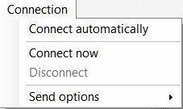

***Connect automatically***  
Select to let RSMPGS1make automatic connection attempts to the supervision system. In RSMPGS1.INI, the interval for connection attempts are configured.

***Connect now***

Immediately performs a connection attempt, which is done regardless if *’connect automatically'* has been marked or not.

***Disconnect***

Closes the connection. If *’connect automatically’*is marked, a connection attempt will be performed within the stated interval.

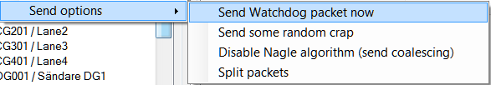

***Send options – Send watchdog packet now***  
Sends a watchdog package

***Send options – Send some random crap***  
To test the resilience of supervision system regarding incoming junk data. It randomly produces 2048 bytes between *0x00..0xff*. Just like an ordinary Json package it is terminated with *0xc0 (formfeed)*.

***Send options – Disable Nagle algorithm (send coalescing)***  
This alternative affects the algorithm usually used in TCP to make the sending of many small packets more efficient. Ordinarily these are grouped together in larger packages.

RSMPGS1 is buffering all JSon packages with the C# function *NetworkStream.Write()* in two calls, where the first is the serialized data and the last is the packet termination character *0x0c (fromfeed)*.

If the algorithm is shut off, there will always be two packets out on the network. The purpose is, just like the next function, to test the buffer algorithm and packet decoding of supervision system.

***Send options – Split packets***  
This alternative splits all packets randomly and sends them in small packets, 1..10 bytes each and 10 ms break between each packet. The purpose is to test the buffer algorithm and packet decoding, which are common error causes, and which may be hard to detect.

## View

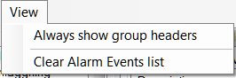

***Always show group headers***  
If a parent node is selected in the Sites and Objects list view all its children will populate the listview in the selected tab (Alarms, Status, Commands). To separate them they will be grouped and there will be a group header. If only one child is selected by default the group header is not shown but will be shown if it is selected here.

***Clear Alarm Events list***  
This will clear the alarm event list (it does not change any status)

## RSMP

RSMP protocol specific settings have an own tab. The simulator could be used with RSMP protocol versions 3.1.1..3.1.4

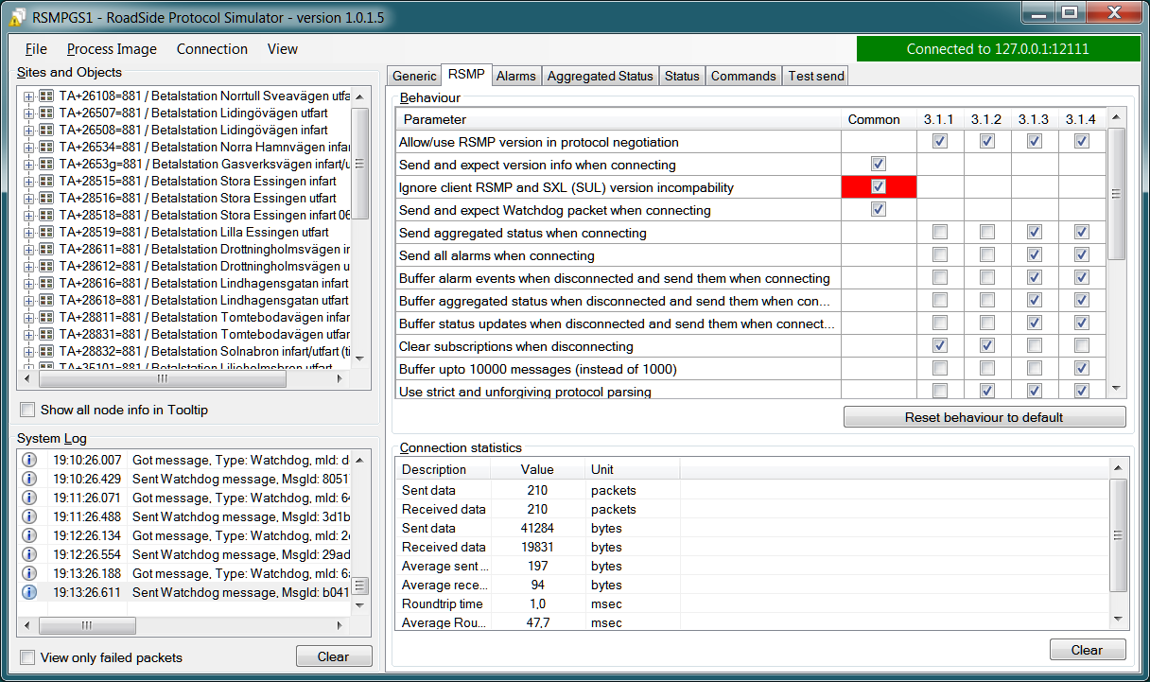

***Behaviour***

The protocol behaviour could be adjusted to test different functionality. The settings could be changed for each version of the RSMP protocol (not common settings). If any setting deviate from the default setting, it will be indicated by a red background.

The RSMP versions the simulator will allow and use when connecting are selected by the first row.

The setting *Use strict and unforgiving protocol* parsing enables a more strict mode, where amongst other protocol checking all JSon names and (where applicable) values are case-sensitive.

Each individual setting is not explained in this document, since they mostly reflects the version document history of the RSMP protocol and the protocol specification itself, hence are pretty much self-explanatory.

***Connection statistics***

Some statistics (sent bytes/packets etc) are viewed here. Select *Clear* to reset them.

## Alarms

Alarms are read from SXL and created for each object type, which means the same *AlarmCodeId* may occur on several objects.

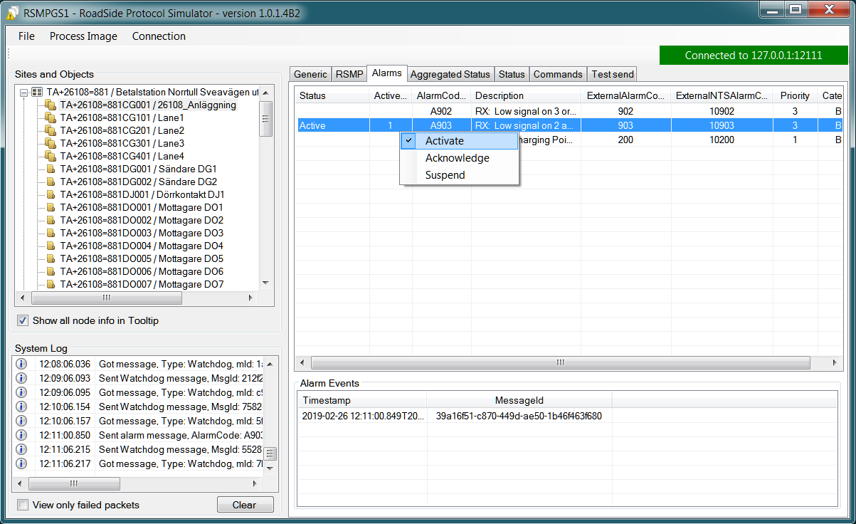

At the bottom, *Timestamp* and *MsgId* are shown for occurred events.

Select the alarm that should be tested and select from the pop-up menu with the right button.

***Activate***  
Sets the alarm in active status (alternatively *Inactive*) and creates an Alarm-message with *aSp == ’Issue’*. The alarm automatically gets the status *Acknowledge = false* when activated.

***Acknowledge***  
Sets the alarm in *acknowledged* status and creates an Alarm-message with *aSp == ’Acknowledge’.*

***Suspend***  
Sets the alarm in *suspended* status (alternatively not suspended) and creates an Alarm-message with *aSp == ’Suspend’*.

***Alarm Events***

Alarm event history, *Timestamp*, *MsgId, AlarmCodeId* and *Event* are shown for sent and received events.

## Aggregated status

Aggregated status is normally compiled on each grouped object of the road side equipment. RSMPGS1 lacks that kind of dynamic, the reason for this is that it is hard to keep track of which objects that are put in alarm mode. Consequently, status is configured manually.

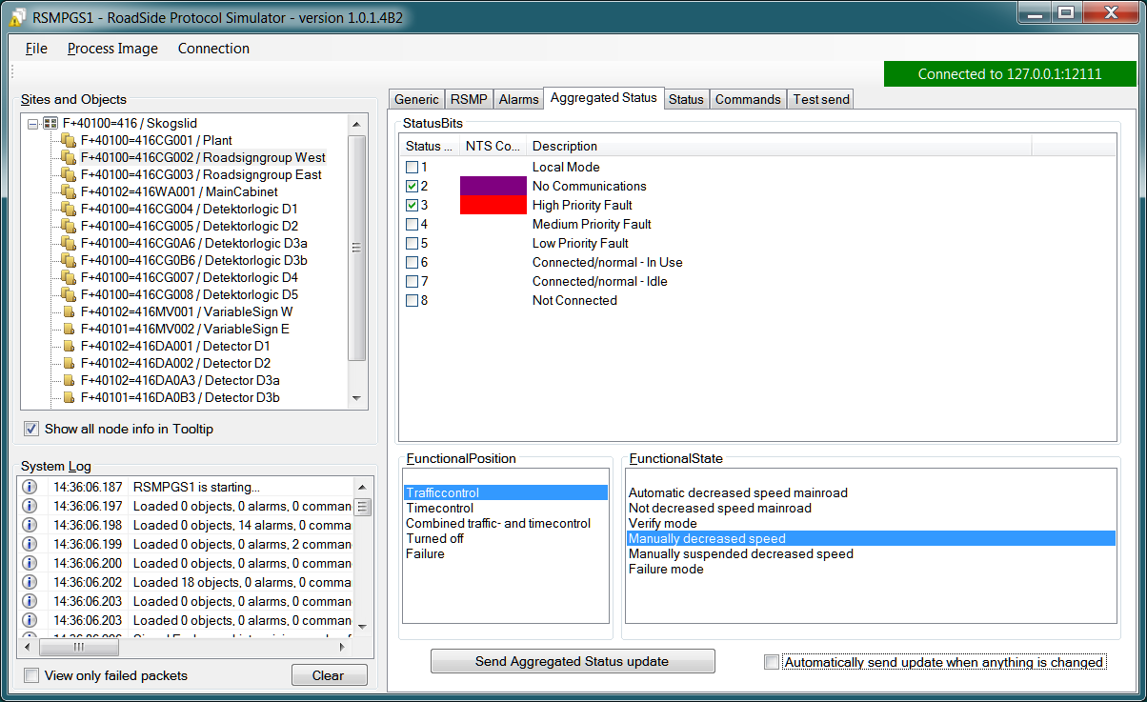

***Status bits***  
Double click to change bit status, on or off. Bit-texts are sourced from *RSMPGS1.INI*. The colors follow NTS standard.

***Functional position***  
Click to choose a *Functional Position*. The empty field set *Functional Position* to *null*.

***Functional state***  
Click to choose a *Functional State*. The empty field set *Functional State* to *null*.

Both *FunctionalPosition* and *FunctionalState* are read from SXL. Any ’-’ are automatically removed.

***Send aggregated Status update***  
Send an *’AggregatedStatus’* message.

***Automatically send update when anything is changed Status update***  
Select to send an *’AggregatedStatus’* message each time something has been changed.

## Status

Status is sent to the supervision system after requests or cyclically/at changes when the supervision system is subscribing to them.

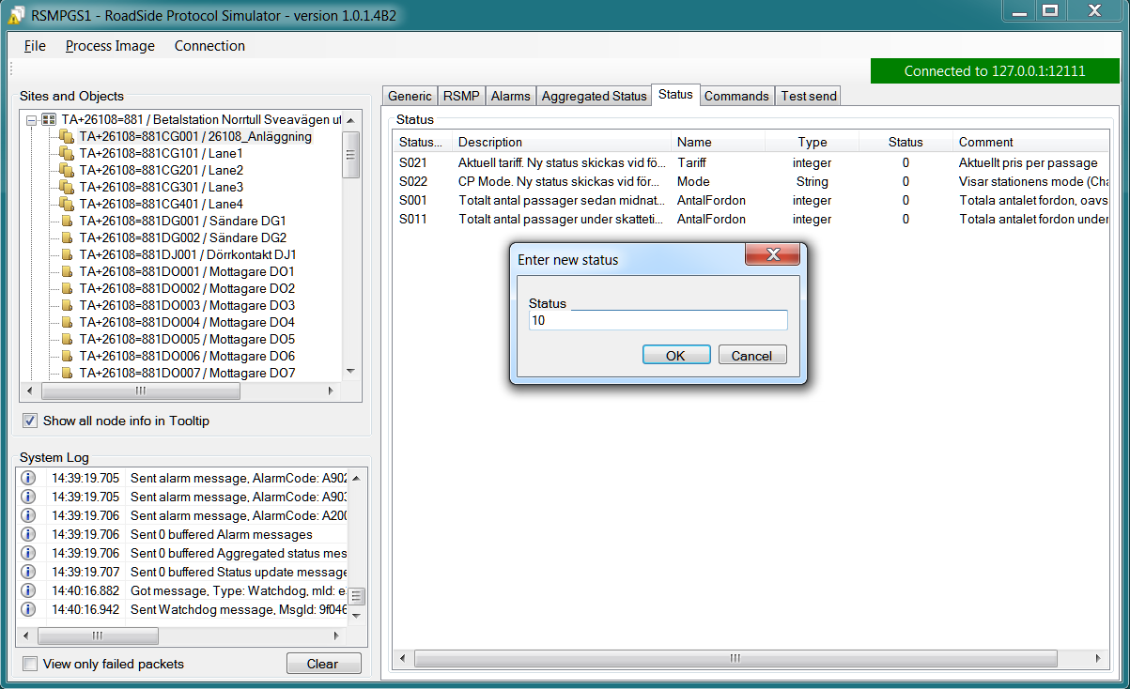

To change status, double click in the *’Status’*column at the value that should be changed. At startup, a question mark is shown which will result in that the value which are sent up becomes *null (unknown).* If the value is manually changed, it will get the status *’recent’*.

Values can be set to any value, all values are sent up as *’string’,* which means that it can be tested how the supervision system reacts to invalid values.

If the data type is *’base64’,* an extra button*’Browse’* will be shown when double clicking *’status’* and a file can be selected, for example a bitmap.

Alternatively, the path to the file can be entered. If there is at least one ’\’ in the status field RSMPGS1 assumes that it is a file path/name and that the file should be base64-encoded and sent. If not, the field is sent as-is.

Please note that RSMPGS1/RSMPGS2 has limited buffer size and it cannot receive files larger than 2 MB.

In subscription mode, new status is sent directly when it has has changed if the subscription parameter *UpdateRate*is set to *0*, in other cases when the interval expires next time.

## Commands

The Commands tab displays the values which have been sent from the supervision system. At startup, only question marks are shown.

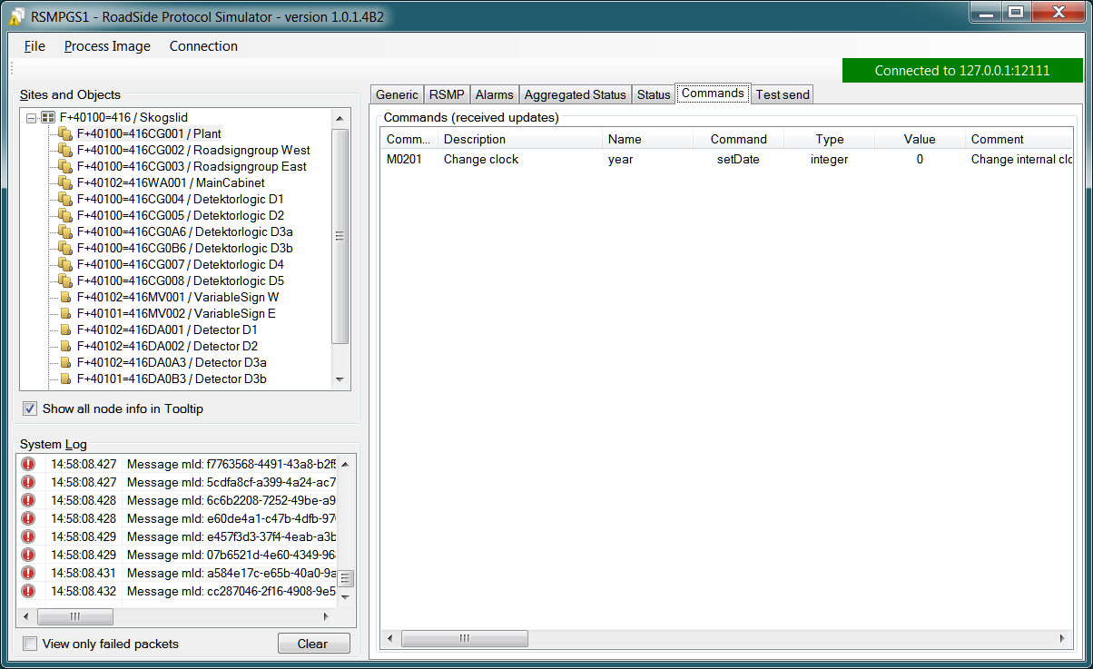

RSMPGS1 makes a basic check that the value is kept within the limits of the data type. If the value seems invalid, an error message is shown in the system log.

## Test send

JSon is text based and in this tab text files can be sent as is. The files may be JSon debug data from the debug-forms.

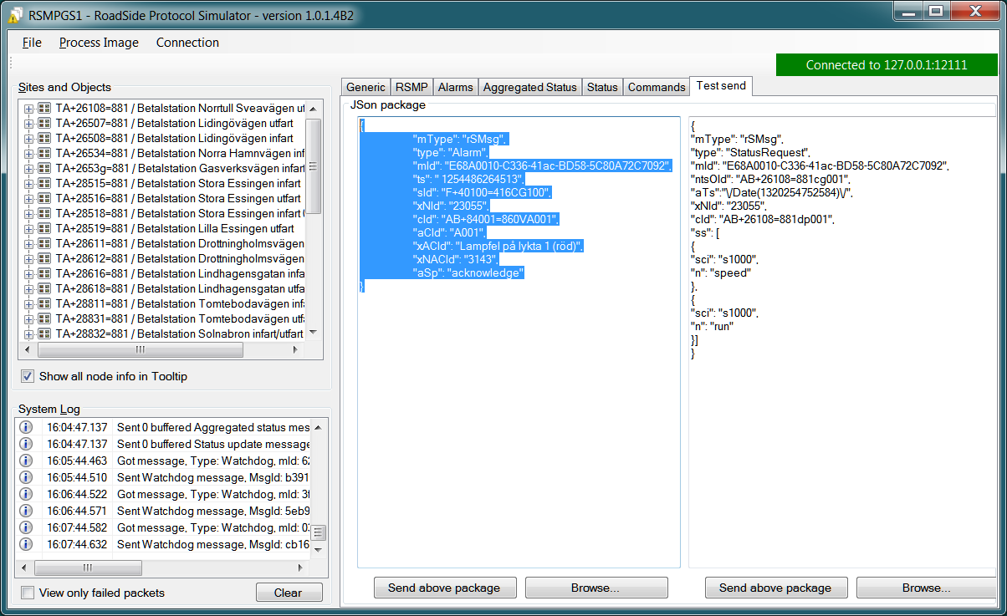

There are two textboxes which can be used simultaneously. In the textboxes, it is possible to copy/paste text as desired.

***Send above package***  
Sends Json message in textbox above. The ending *0x0c (formfeed)* is automatically added at the end.

Please note that RSMPGS1 does not remove CR/LF or tabs in the text before it is sent.

***Browse***  
Open and read a text file inte the above text form.

# Debug form

The Debug form shows sent and received data more or less formatted depending on chosen display format.

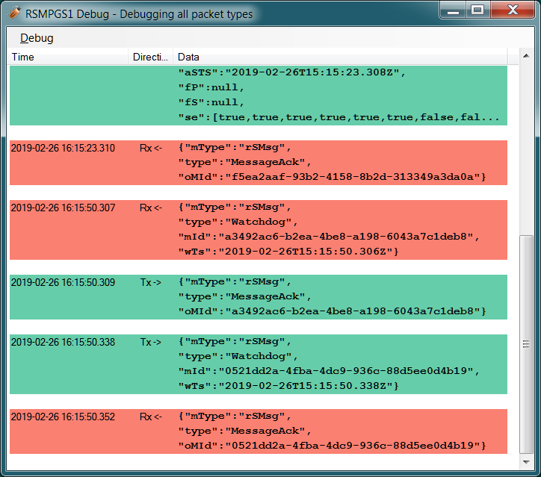

The red texts are messages which are received, green texts are the ones which are sent out. The time stamp has millisecond resolution which is shown if the column is expanded somewhat.

If show raw data is not selection, then RSMPGS1 will format the text for better readability. If there are CR/LF and tabs in the received Json, these control characters will be used to increase readability. If not, RSMPGS1 will use a set of simple rules to format the text.

RSMPGS1 is always removing CR/LF, tabs and finalizing form feed (FF) before deserializing.

Time stamps are also presented decoded in both *UTC* and *local time*.

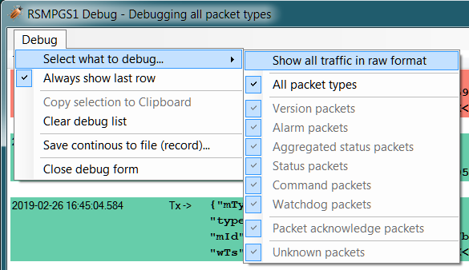

***Select what to debug – Show all traffic in raw format***  
Shows all packets unformatted in raw data format. ASCII codes which RSMPGS1 is not certain if they are writable are shown as <ASCII> i hex-format, e. g.<0x0c>for*formfeed*.

***Select what to debug – All packet types***  
Shows all packet types.

***Select what to debug –Version packets, Alarm Packets etc…***  
If not all packet types are selected to be shown, one packet type or a selection of packet types can be selected for display. Because that it is possible to display any number of debug formulas, it is possible to have different types of formulas for every packet type.

***Copy selection to Clipboard***  
In the debug window, it is possible to select one or more lines and copy to the clipboard with this function. RSMPGS1 delimits every line with CR/LF *(0x0d/0x0a)* as text in the clipboard.

Every column is delimited with a tab *(0x09).*

***Clear debug list***  
Empties the debug form.

***Save continuous to file (record)…***

Begins a recording to file from this specific debug window.

File name and file location are determined by the user. RSMPGS1 suggests the folder name*\LogFiles\DebugFiles.*

If the file does not exist it will be created and filled up with new debug data. The same data which is presented in the form is stored in the file. The file is an ordinary text file and will be flushed every 100 milliseconds. Because of this, it can be copied or opened (only for reading) with complete contents without having to be closed first.

To close the file and stop recording this option must be unchecked (it will be checked when the file is opened and recording is in progress).

***Close debug form***Closes the debug window.

# Change log

|  |  |  |  |
| --- | --- | --- | --- |
| Version | Document date | Change | Name |
| RevA | 2011-12-06 | First version of the document | Tomas Rook |
| RevB | 2012-08-24 | Change of template | Johan Thell |
| RevC | 2019-02-26 | Updated for new release of simulator | Tomas Rook |
| RevD | 2020-03-26 | Updated for new release of simulator | Tomas Rook |
|  |  |  |  |